ONG JIA AUN WEA150022 Tutorial 11

1. Draw a neural network architecture with 3 input nodes, and 1 output node, and a hidden layer with 2 nodes. Label the network components. Assume it has mesh connection between the layers. [6 marks]

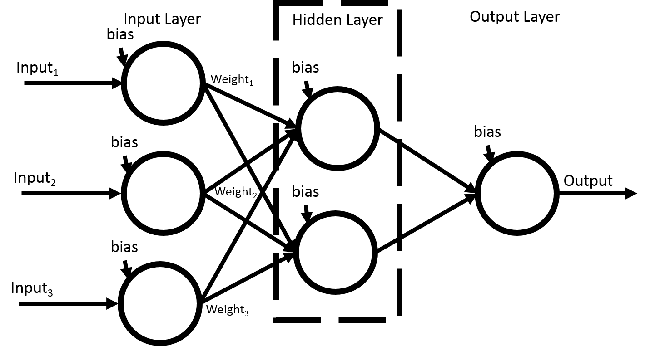

2. Write the pseudocode for K-means clustering algorithm. [4 marks]

- Initialize number of cluster: k

- Initialize random vector of means: m=[ ]

- Classify each input data according to mean

- Update the cluster means (centroid) until no change

- Repeat step 2 and 3 until convergence had been reach

3. Identify a weakness of K-means clustering algorithm. [1 mark]

- Unable to handle outliers

- User has to specify K

4. Give 2 limitations of recurrent networks. [2 marks]

- Very difficult to train

- Have a tendency to learn something that isn’t expected

5. What are the advantages of unsupervised networks compared with supervised networks? [2 marks]

- No need supervision / prepare desired output (labeling)

- Able to identify patterns that might not be clear to human

6. The Malaysian national flag consists of 4 colors and many shapes. Each region of a specific color can be considered as a segment. Is SOM suitable for identification of each segments in the flag? How should we format the input data for SOM processing? Provide your assumptions. [5 marks]

- Yes.

- Assuming the flag is flat 2D image

- Format into by pixel

- Each data point represents a pixel in the image of the flag and has a value representing the color

- eg. (coord_x, coord_y, RGB)

- Topology